EPA, HUD and DOT announce interagency partnership to promote sustainable communities
- By Robin Snyderman, Vice President of Community Development
- October 7, 2009

In an historic joint March 18 appearance before the House Appropriations Subcommittee on Transportation, Housing and Urban Development, U.S. HUD Secretary Donovan stressed that his agency's "central mission - ensuring that every American has access to decent, affordable housing - can be achieved only in the context of housing, transportation and energy costs and choices that American families experience each day.” U.S. DOT Secretary LaHood concurred, adding in his testimony that transportation investments should "revitalize our downtowns, foster walkable neighborhoods and bring people, employers and housing closer together... Livable communities are essential to a vibrant, sustainable America," LaHood said.
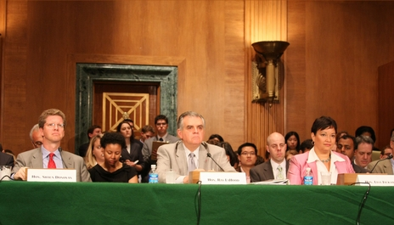
U.S. Secretary of Transportation Ray LaHood (center), Secretary of Housing and Urban Development Shaun Donovan (L), and EPA Administrator Lisa Jackson testify before Congress June 16, 2009 in Washington, DC.
On June 16, the Environmental Protection Agency (EPA) joined the partnership, and the Partnership for Sustainable Communities established six livability principles, providing a foundation for interagency coordination. "We're leading the way towards communities that are cleaner, healthier, more affordable, and great destinations for businesses and jobs," said EPA Administrator Lisa P. Jackson. Their joint announcement vowing interagency coordination in support of sustainable communities is a poignant step forward for our region, and for MPC’s long-held message that federal and state dollars should reward good planning and proposals that link housing, transportation and jobs. Metropolitan Chicago will enjoy a better range of quality housing options located near good jobs and good schools if, as suggested in this announcement, infrastructure and transit investments are encouraged and rewarded for contemplating nearby housing affordability and if housing investments are rewarded for supporting transit use.
The joint announcement exemplifies the slow but steady federal policy shifts toward rewarding collaboration between agencies and communities. This news should induce Illinois and metropolitan Chicago to further pursue regional collaboration and develop in a way that makes us competitive for federal resources rewarding such efficiencies. To seize the opportunities in Illinois created by this federal announcement, the first steps are to:
. Pass the Transportation Investment Accountabilty Act and a Capital Investment Plan, deploying a creative combination of incentives - including the new housing dollars in the Governor’s proposed Capital Bill - to support this new federal agenda.
. Fund the (already passed) Local Planning Technical Assistance Act and Good Housing Good Schools legislation, to implement sound planning and development strategies.
. Pass the Livable Communities Act, S. 1619, introduced by Sen. Christopher Dodd (D-Conn.). Contact your U.S. senators and encourage them to support the Livable Communities Act. Send this sample letter of support or call and use the letter as talking points.
In addition to promoting bottom-line budget efficiencies, these actions would quickly fast track local efforts to reward good proposals and create more livable communities right here in Illinois.
Already, nearly every aspect of MPC's policy agenda and community development work plan in 2009 is emboldened by this news, including:
. the Reconnecting Neighborhoods recommendations,
. the inter-jurisdictional housing work and nearly all of its Community Building Initiative efforts,
. its evolving Employer-Assisted Housing strategy,
. the Regional Housing Initiative,
. all the housing tools MPC has worked with the Metropolitan Mayors Caucus to develop.

